## Elasticity of Demand – Labor

1. Elasticity of Demand
   1. Labor
      1. MRC = W
      2. Elasticity of Labor = %ΔL/%ΔW
      3. What effects it’s elasticity?
         1. Elasticity of Demand for Product (Output)
         2. Demand for labor is a derived demand
         3. Derived from the output that the labor produces
         4. If you increase the price of the product by 10% and the consumption declines 50%(elastic) then labor is reduced sizably.
         5. If you increase the price of the product by 10% and the consumption declines 2% (Inelastic) then labor is reduced sizably.
         6. Labor share of total cost (TC)
            1. The higher the share of total cost the more elastic
            2. The lesser the share of total cost the more inelastic
            3. Example:

1

Labor represents 20% of total cost

Wages go up 20%

Total wages become 24% (+4%)

2:

Labor represents 80% of total cost

Wages go up 20%

Total wages become 96% (+16%)

You would become more responsive in example 2.

* + - 1. # of substitutes
         1. The more substitutes the more elastic the demand for the labor.
         2. Example:

ATMs being a substitute for bank tellers (elastic)

If you’re a heart surgeon there isn’t a substitute so thus they are much more inelastic

* + - 1. Time
         1. The longer the time period of the consideration the more elastic it becomes
    1. Labor is an upward sloping curve, as wage rate rises quantity demanded increases. However as wage rate rises quantity supplied decreases
    2. Market sets the wage rate
    3. Individual wage rate curve is backward bending
       1. Income vs. substitution effects
       2. 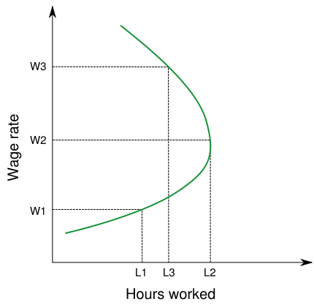
       3. We assume that leisure is a normal good
          1. As income goes up you consume more leisure, thus meaning you are working less.
          2. Example:

The doctor who takes Wednesday’s off to golf, they may lose the thousands they might get from their patient but they can afford not to work.

* + - * 1. The income effect has a better pull at top
        2. The substitution effect has more pull at the bottom
    1. Monopsony
       1. Sole buyer of labor
       2. The only one hiring that skill
       3. Example:
          1. Someone in a small town which grew around a refinery, everybody and their uncle works at that refinery. They in effect are a monopsonist because they’re the only buyer of labor in the area.
          2. You do not have to be a pure monoposist to have monopsony power.
          3. Restricting the purchase of an input reduces the price the buyer must pay.

|  |  |  |  |
| --- | --- | --- | --- |
| L | W | TCL | MRCL |
| 1 | 7 | 7 | 7 |
| 2 | 8 | 16 | 9 |
| 3 | 9 | 27 | 11 |
| 4 | 10 | 40 | 13 |
| 5 | 11 | 55 | 15 |
| 6 | 12 | 72 | 17 |

* + - * 1. Assumption is that they can not wage discriminate
        2. MRPL=MRCL
        3. A competitive market hires more workers than a monopsony and pays a higher wage rate.
        4. Example:

You’re a nurse and there is only one hospital in the whole town. They offer you a wage and thus that’s the only place you can go. They’re the only firm that is hiring, so they have a very big influence on the cost to hire you.

* + 1. Land
       1. It’s fixed in supply, unlike labor or capital which both increase.
       2. The state of Texas is the same size as it was ten years ago.
       3. 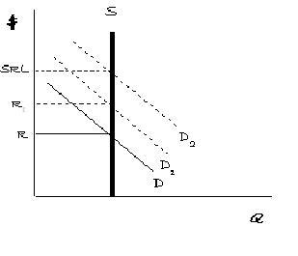
       4. What effects demand?
          1. Proximity
          2. Location
          3. Physical characteristics
       5. Economic Rent
          1. Whenever the owner of a resource is paid more than the minimum necessary to keep the resource in its current supply.
          2. Example: Someone is paid $200,000 per year to do something; truth is they’d be willing to do it for $100,000. They are earning a huge economic rent. They are earning a $100,000 economic rent.
          3. All land is economic rent, even if rent is $0 the land is still there and thus all money earned is economic rent. That is pure rent / economic rent.